

Assignment 1b -Creating and deploying Photo Album website onto a simple AWS infrastructure.

____________________________________________________

COS 20019- Cloud Computing Architecture

Nguyen Manh Dung

20/5/2023

So this is all my step to finish Assignment 1b, belong with detailed explaination

* 1. VPC

I have created VPC which have my name and required instruction.

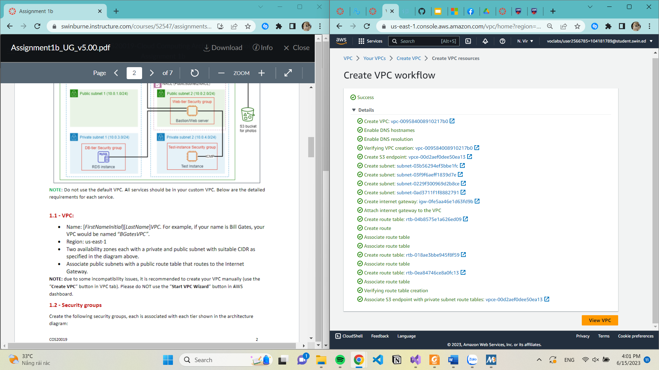

* 1. Create Security groups

5 security groups has been created which fits assignment requirement.

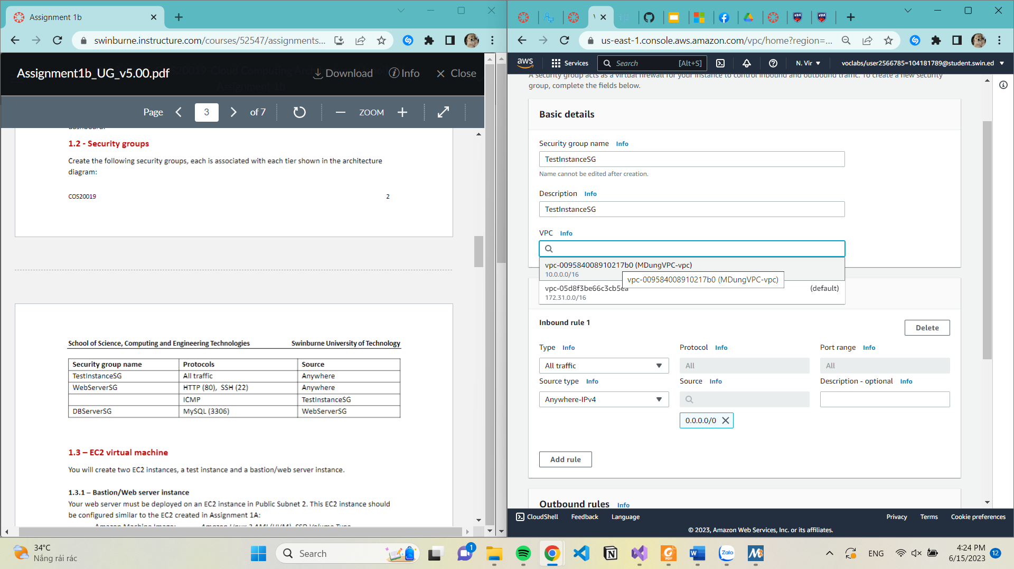

Figure 1: TestInstanceSG security group

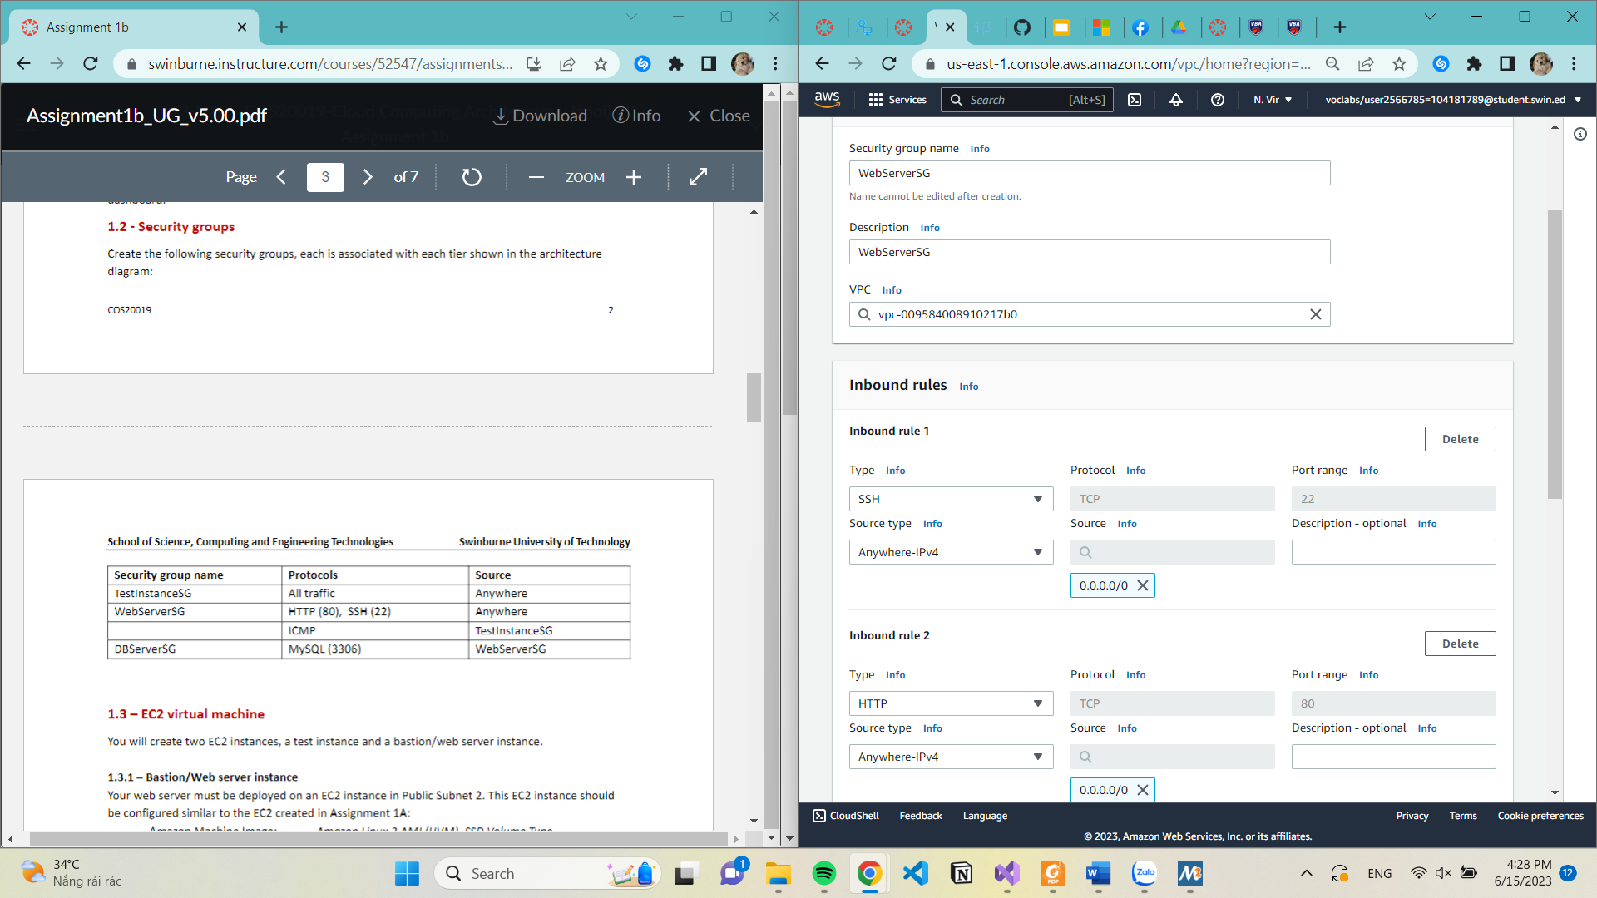

Figure 2:WebServerSG security group, with inbound rules below

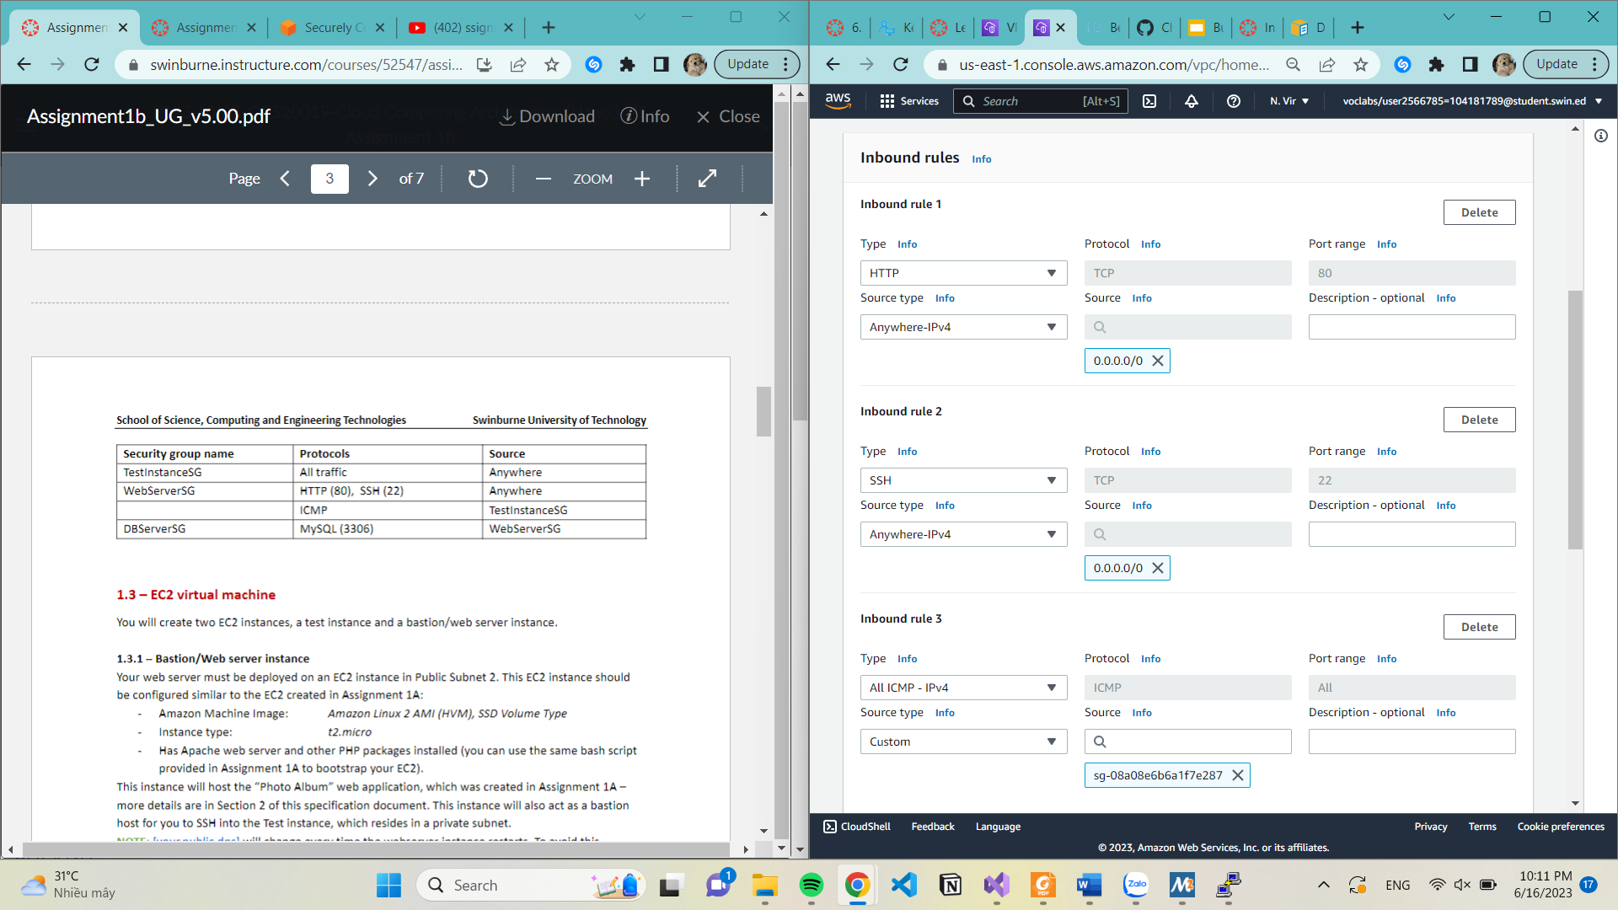

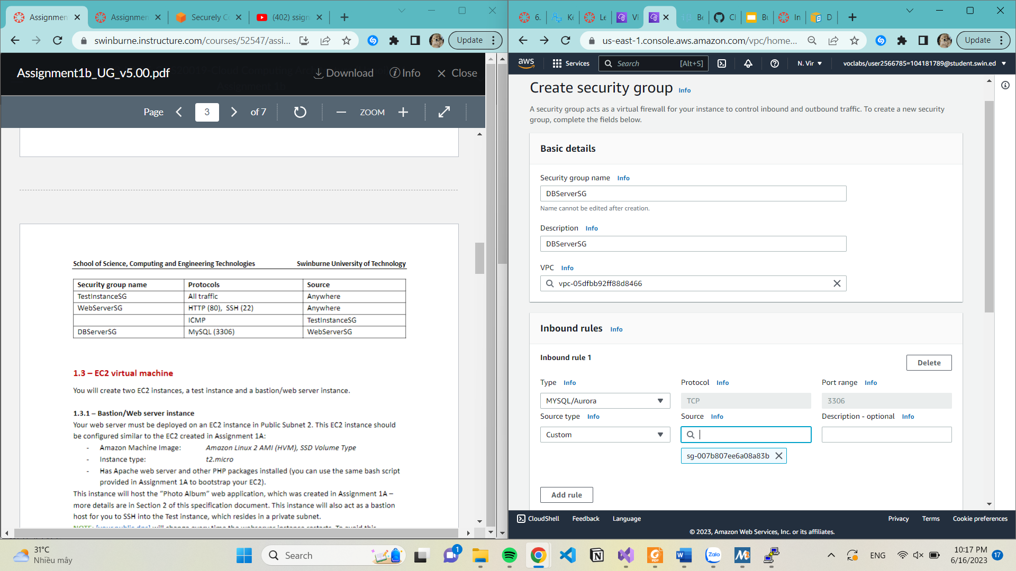

Figure: DBServerSG

* 1. EC2 virtual instance

I have to create two instance which stands for Bastion/Web sever and Test.

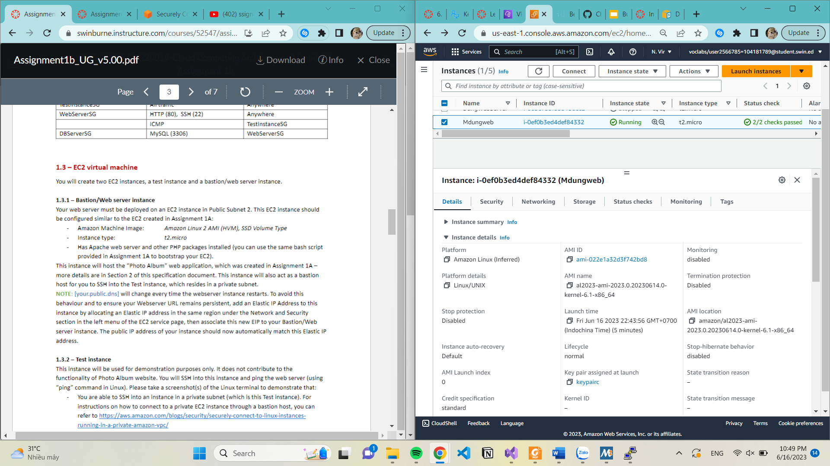

* I have to allocate elastic IP address to avoid my IP to change everytime instance restart.

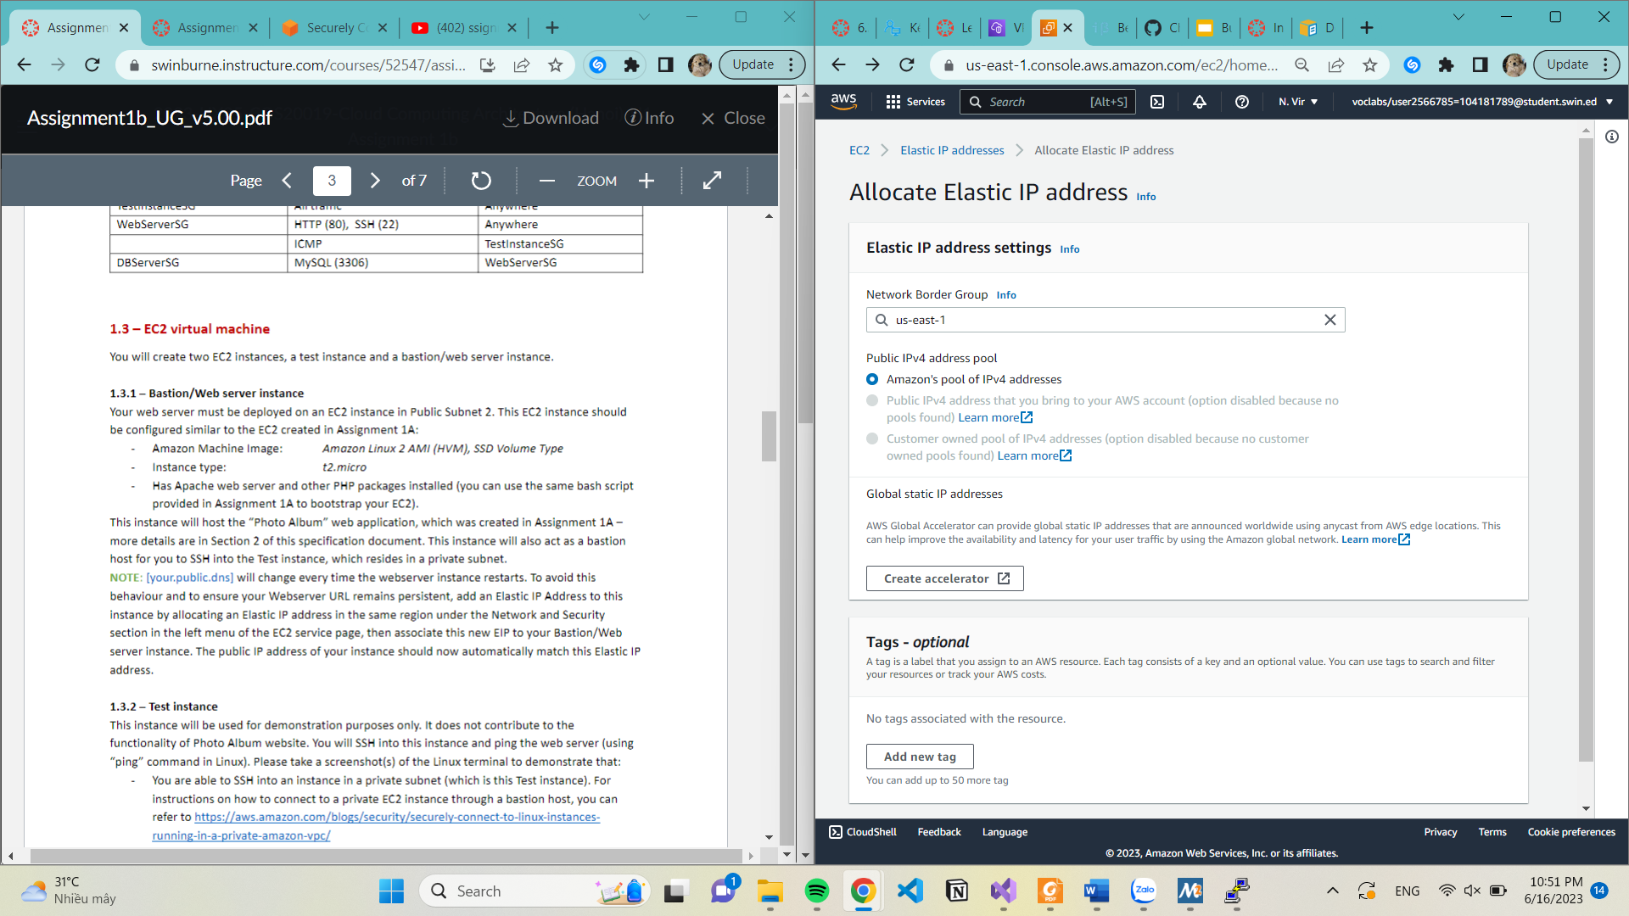

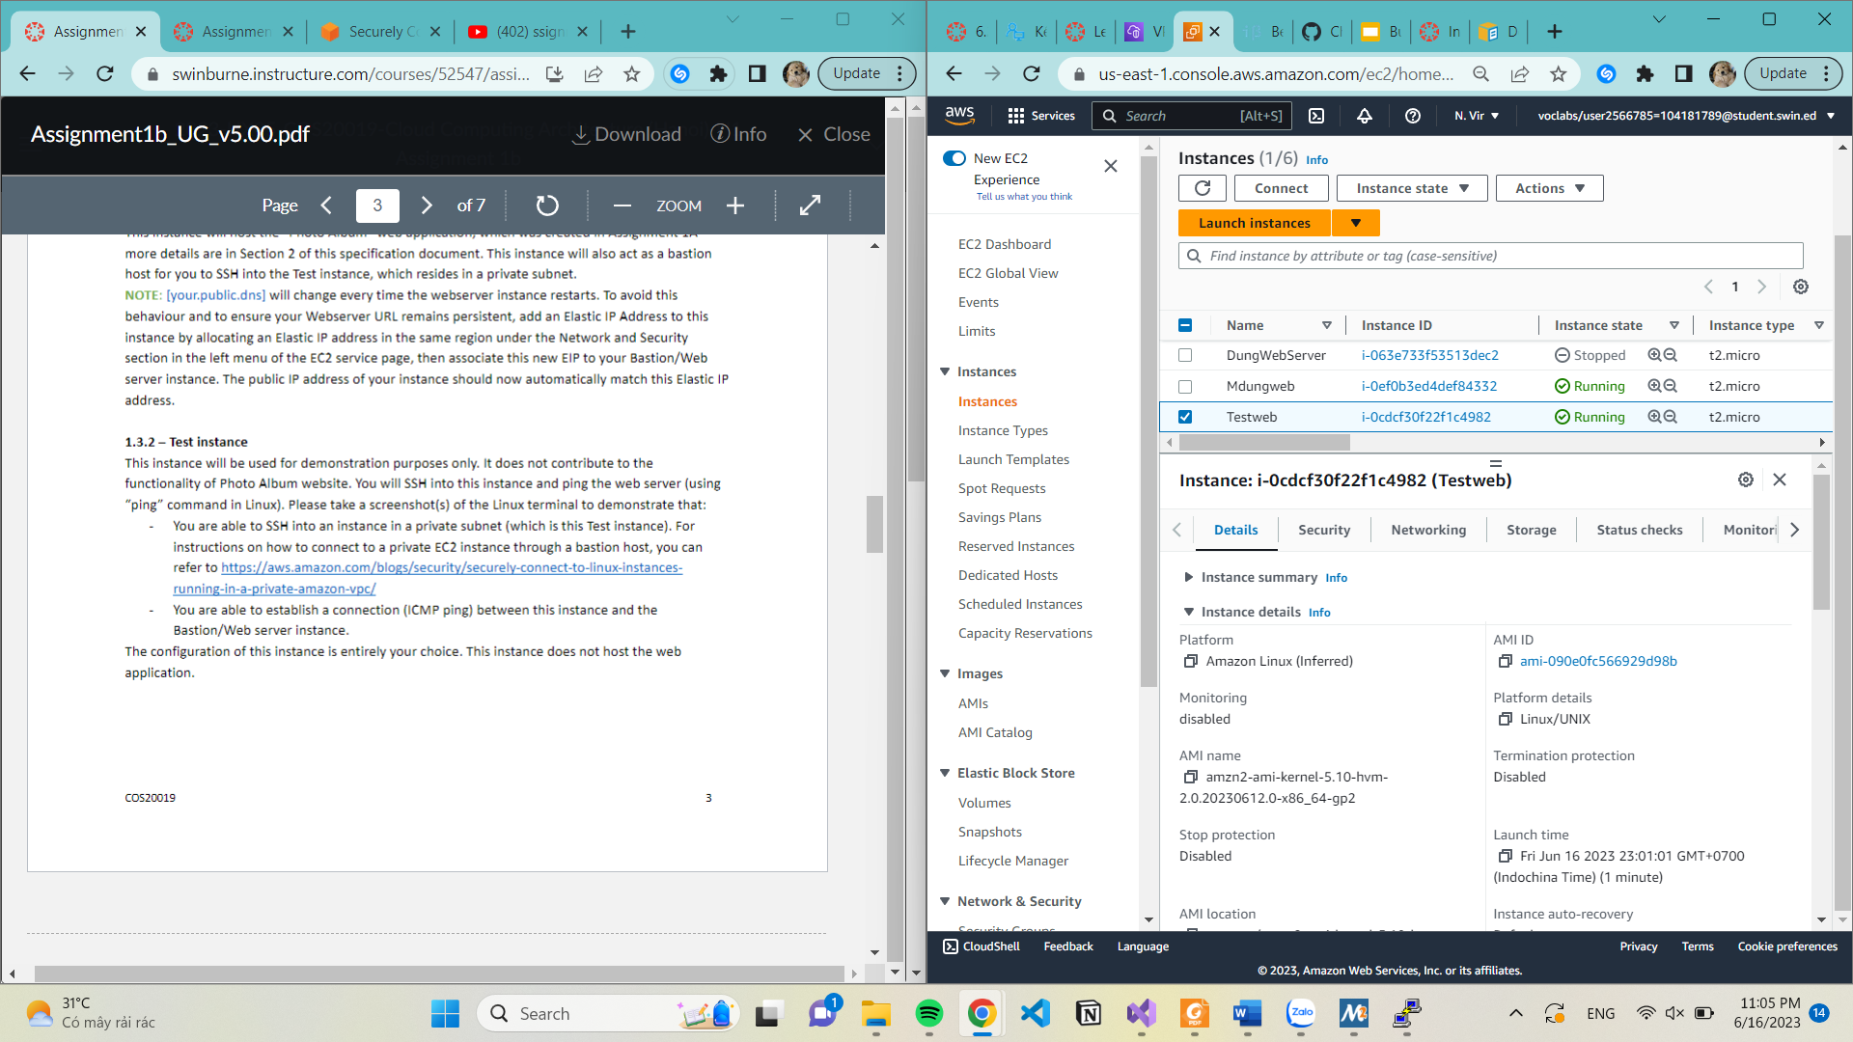

Figure: Test instance sucessful created

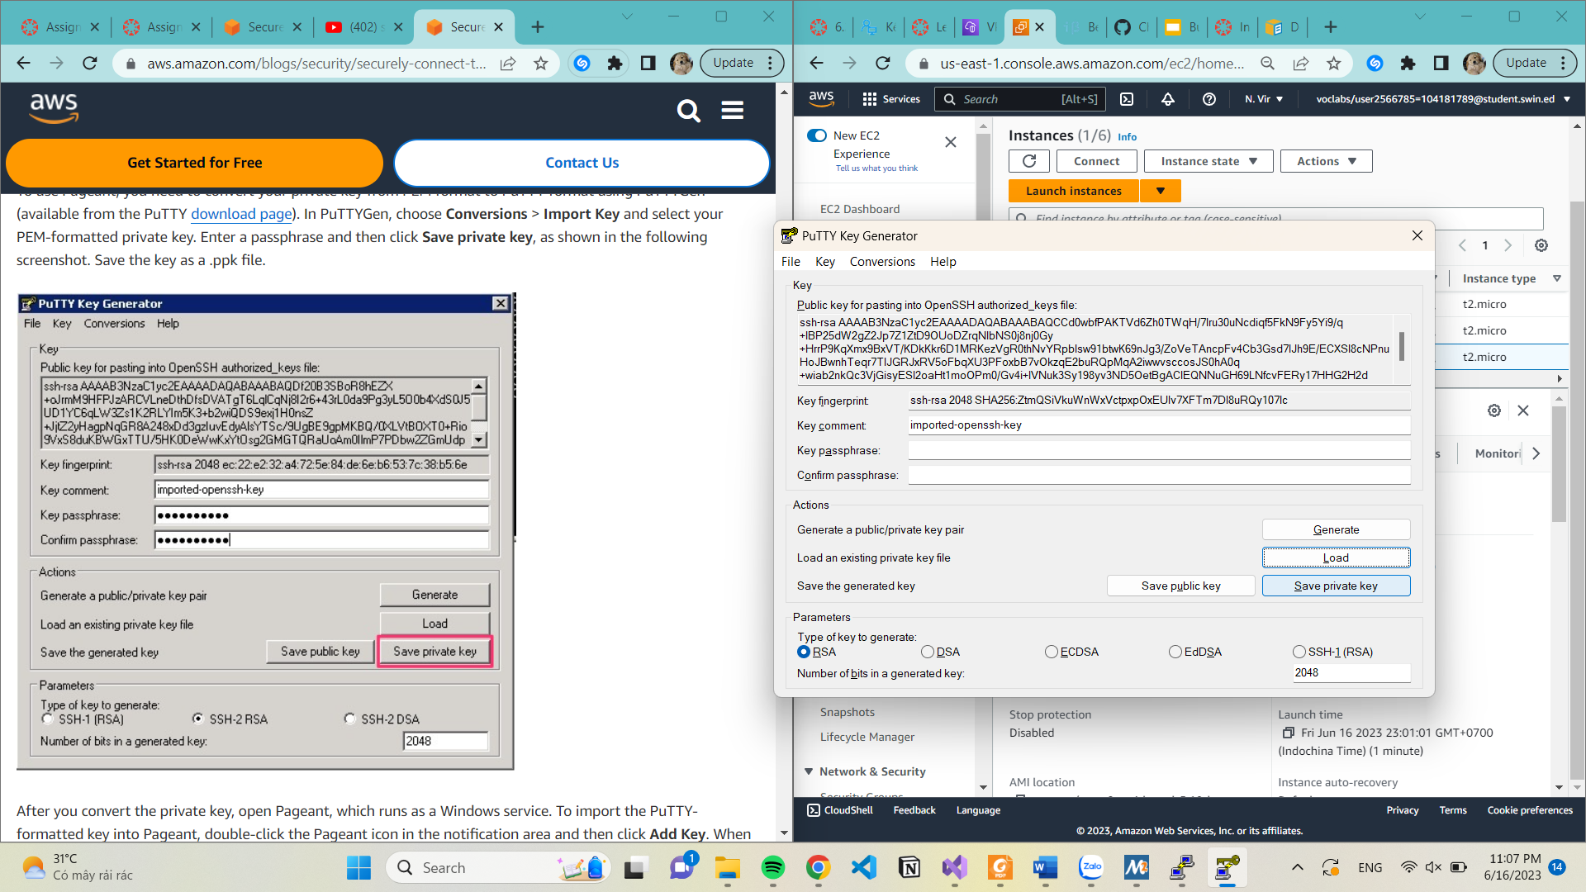

Figure: Above screenshotted is the step to convert the key pair that i created in previous step from .pem to .pkk

1.3.2 This step is to access SSH of Test instance

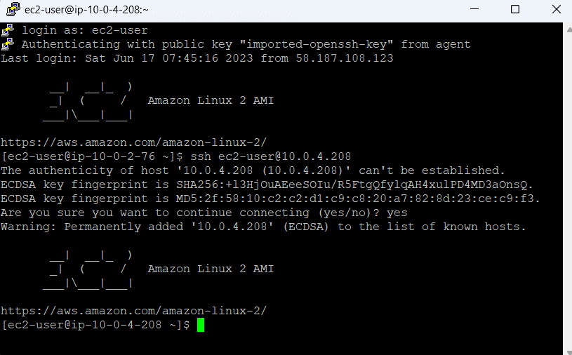

Figure: Access instance

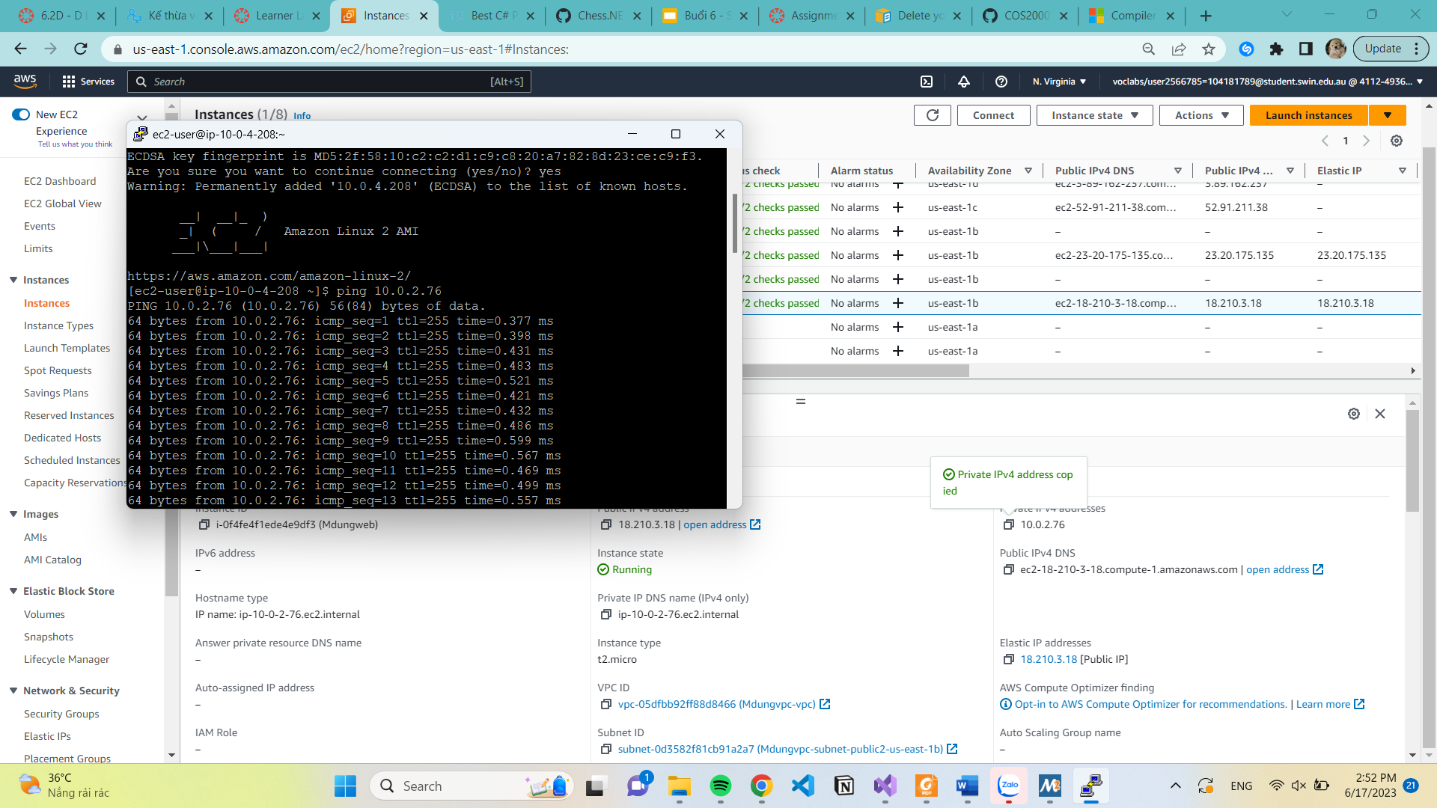

Figure: Establish a connection (ICMP ping) between Test instance and Web server instance

1.4 Create RDS database instance

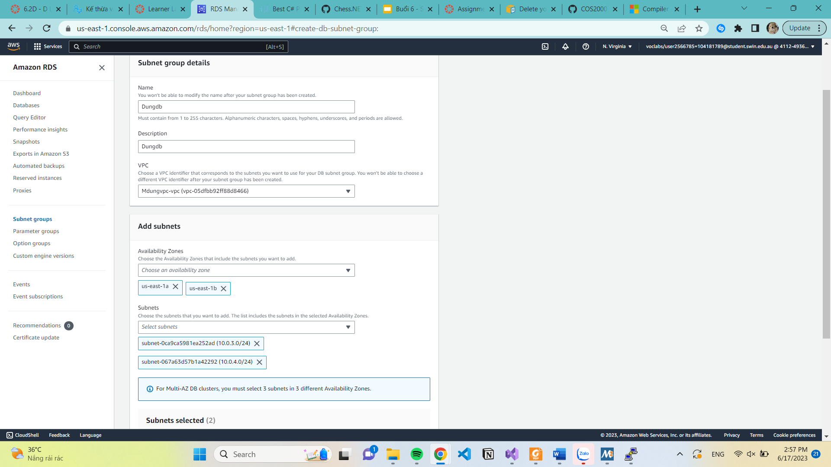

Create database

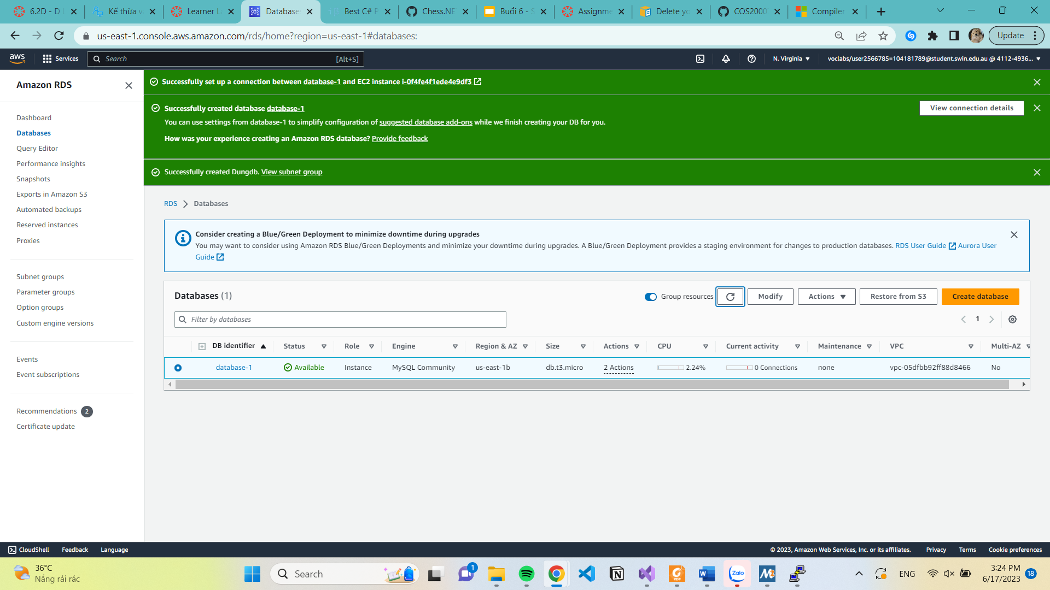

Create a database in your RDS instance with a table called photos that stores meta-data about the photos stored in the S3 bucket. 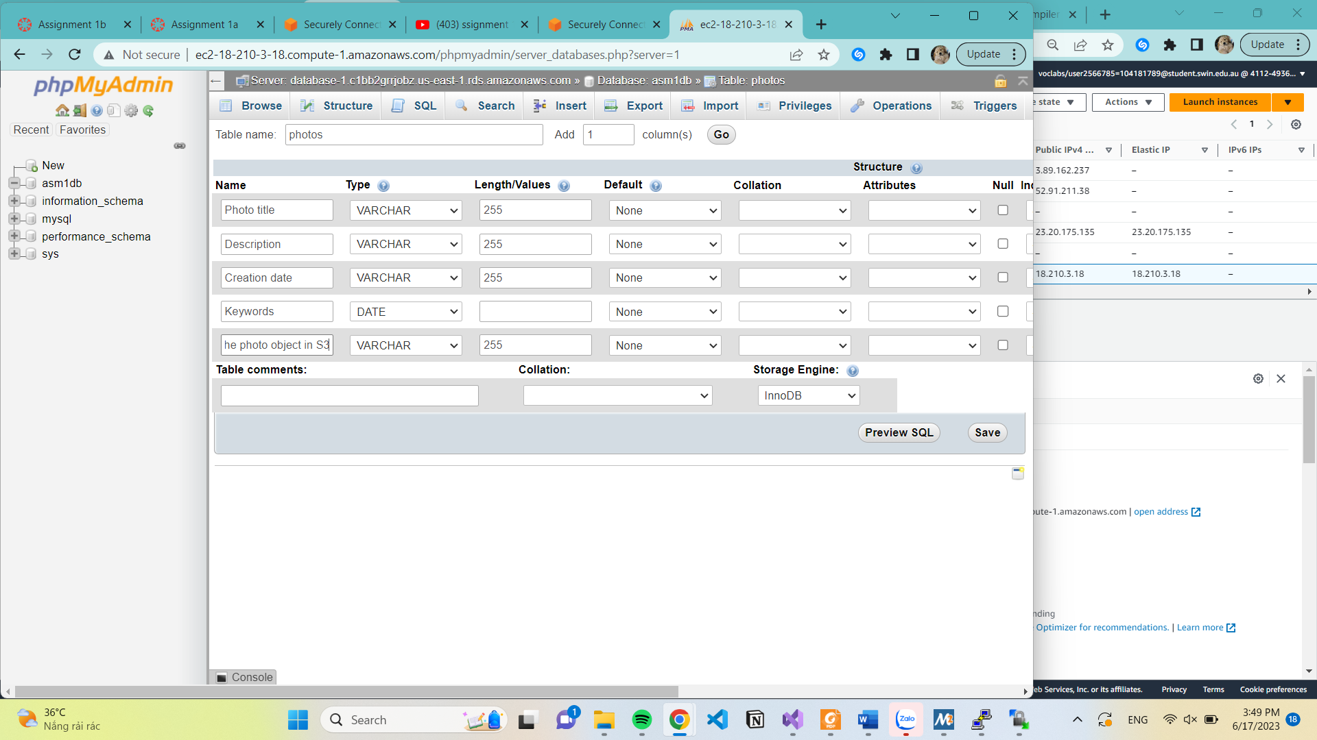

* 1. Create Network ACL

This step is to add an additional layer of security to your web server called Network ACL, below is all the step to deploy it, with all requirement be filled.

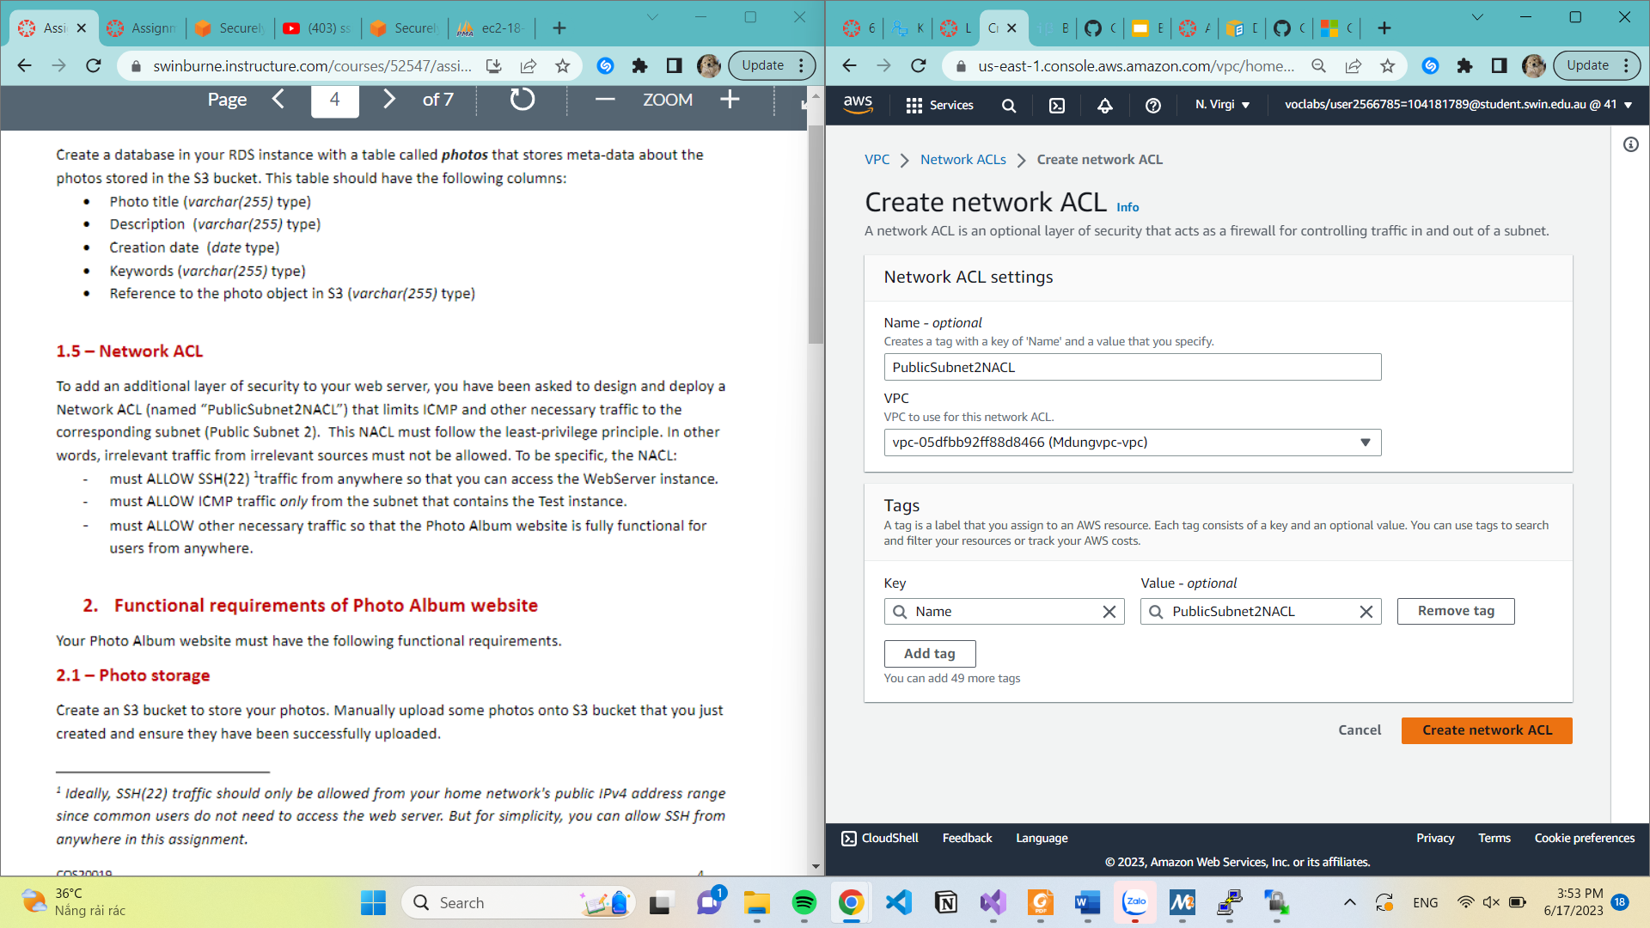

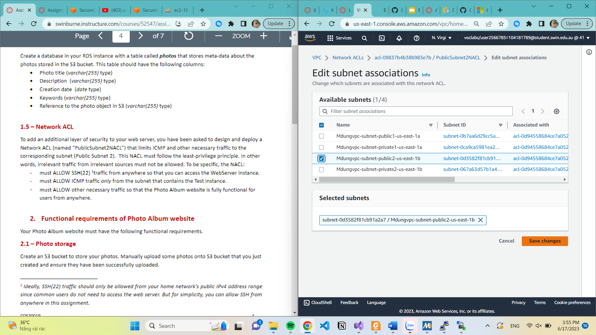

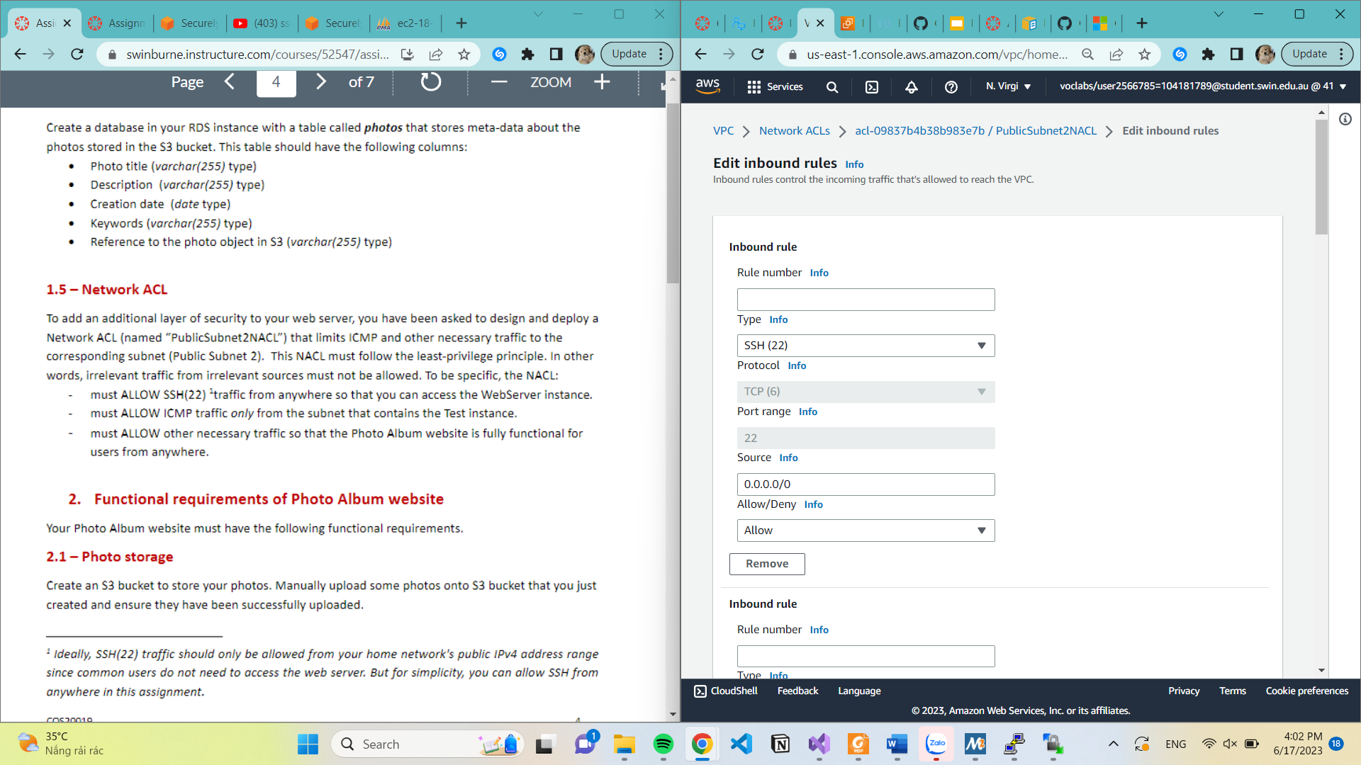

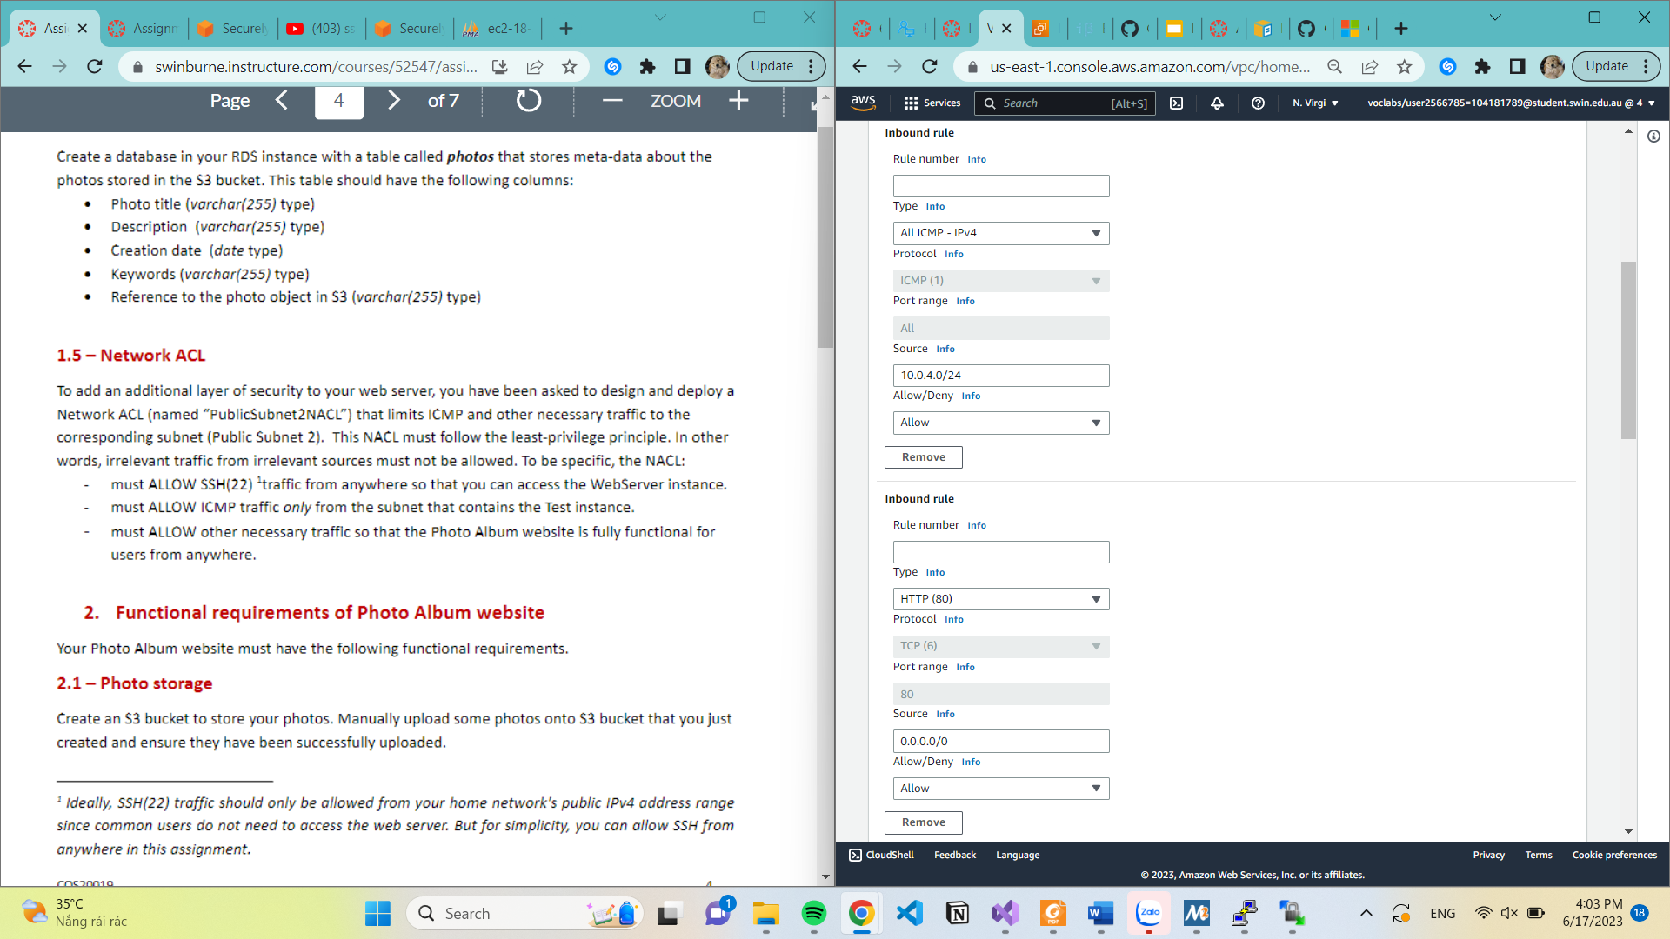

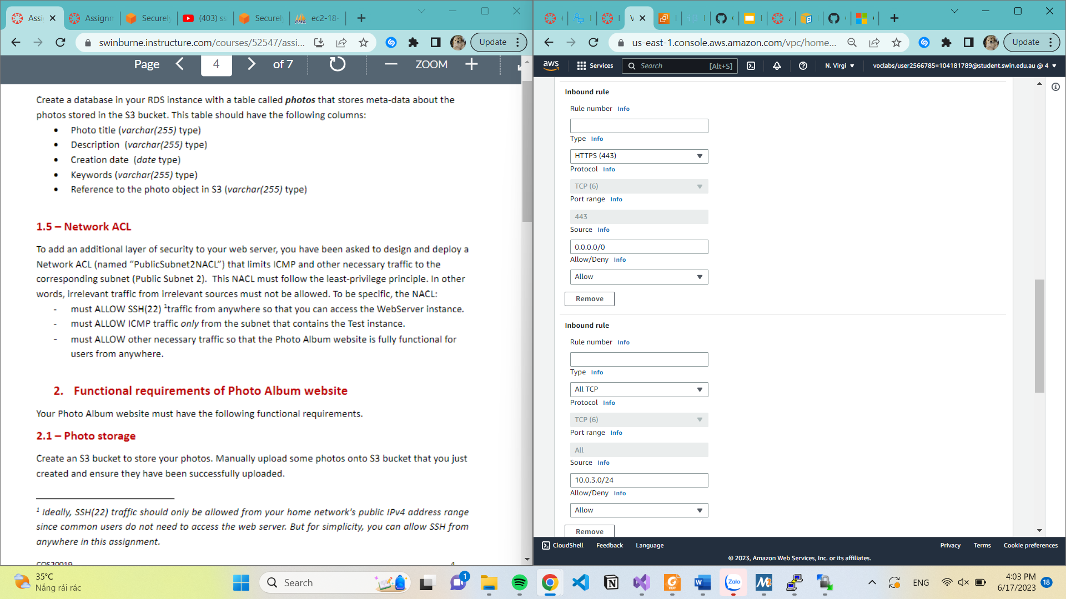

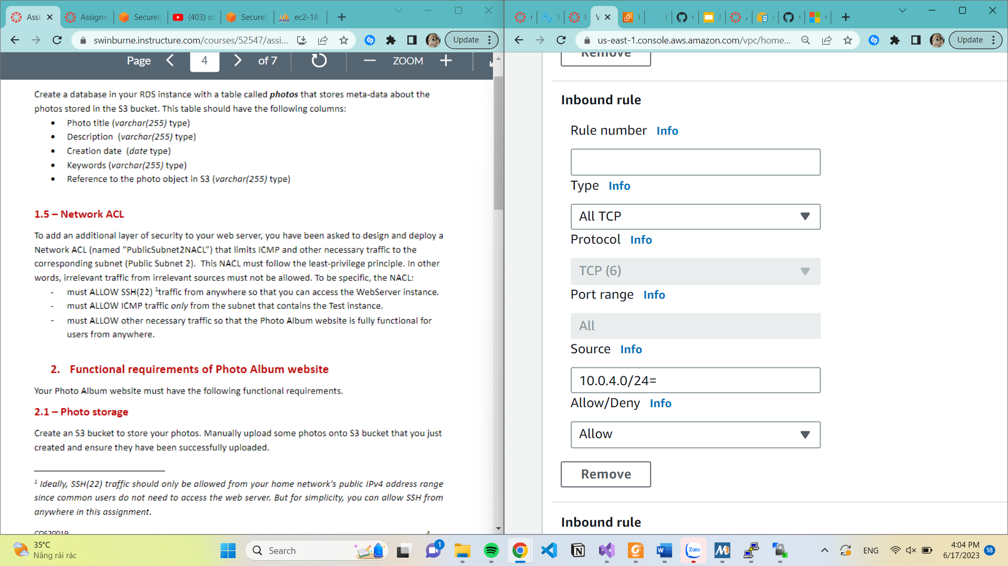

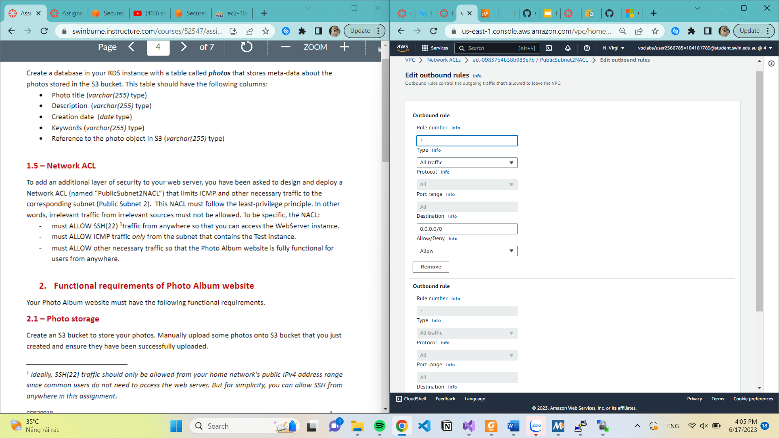

2. Functional requirements of Photo Album website.

2.1 Photo storage

Create an S3 bucket to store photos

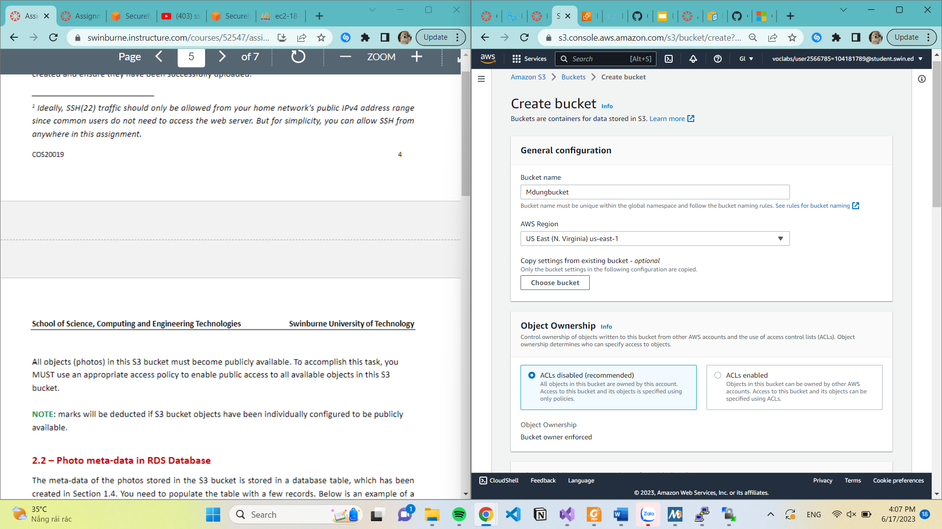

2.2 Photo meta-data in RDS database

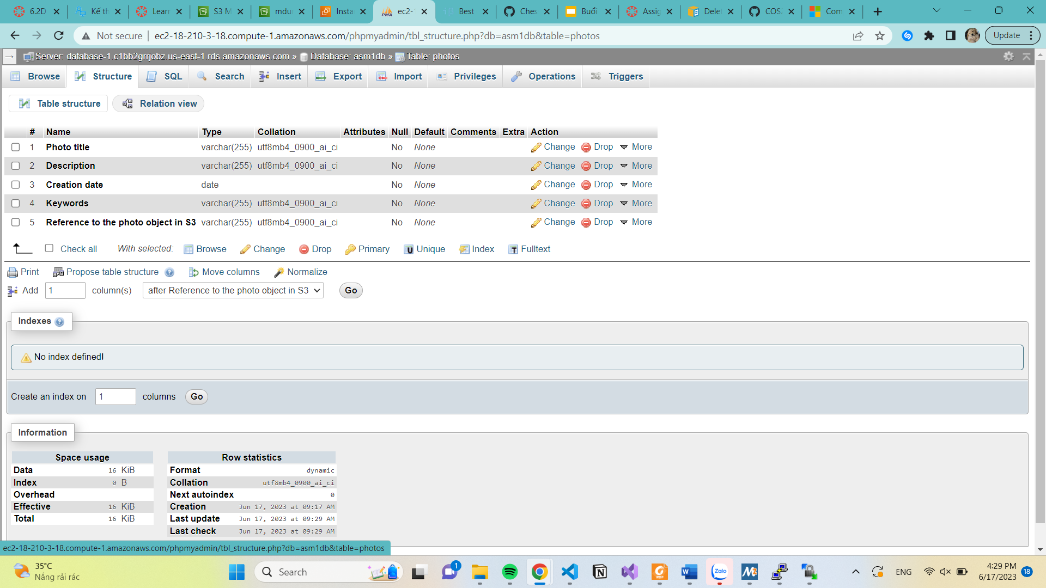

2.3 Photo Album website functionally

I have to create 2 column in the database also modify code in constant.php

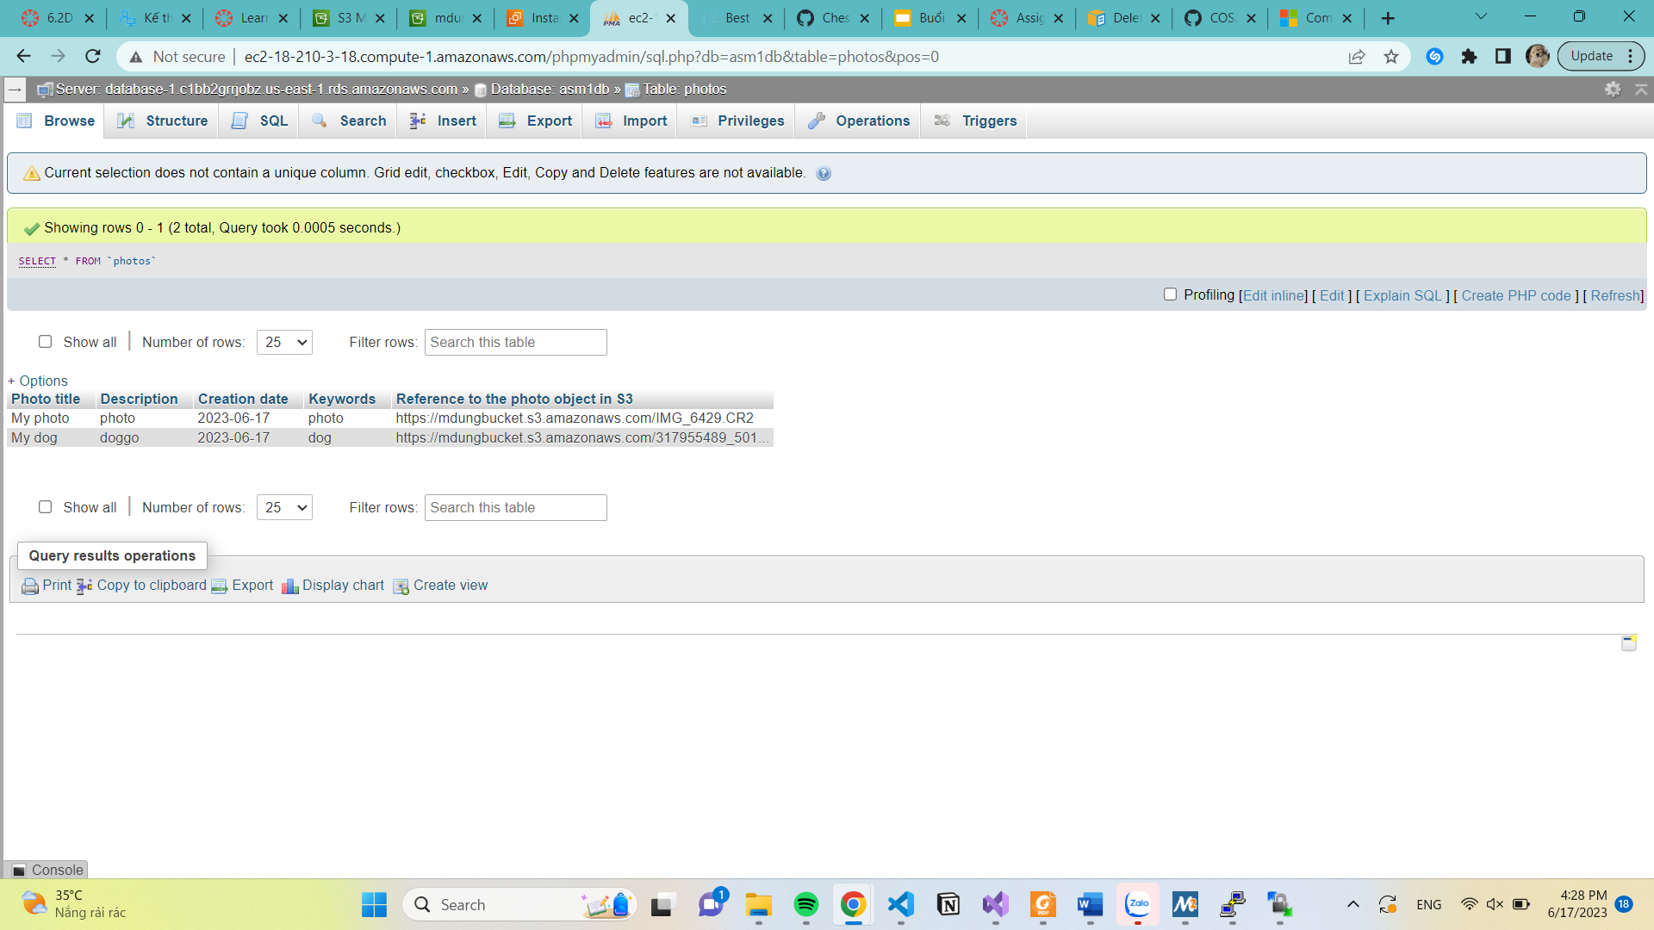

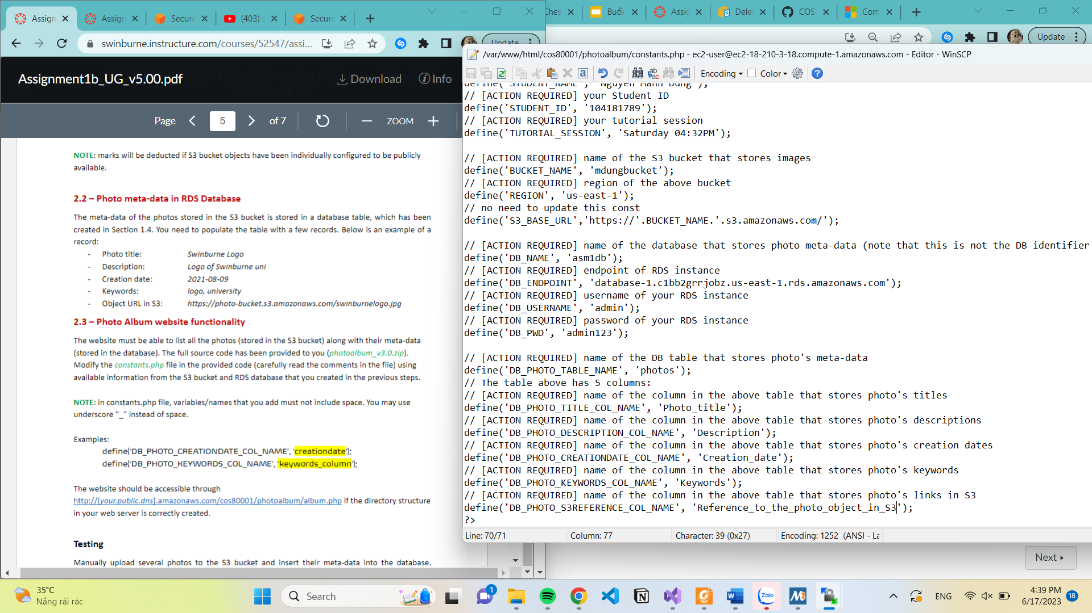

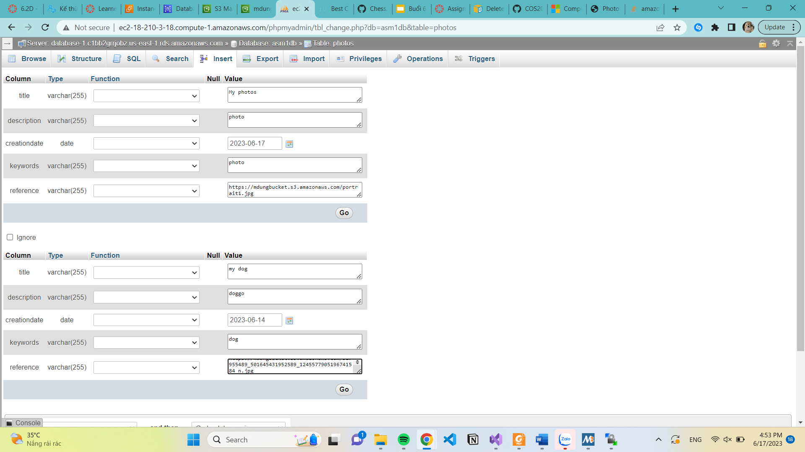

This is my Photo Album website

